**TASK NO 2**

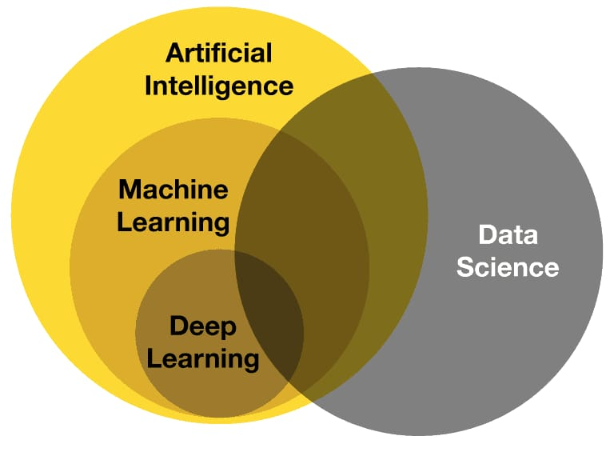**RELATIONSHIP BETWEEN AI ML DL**

The relationship between **Artificial Intelligence (AI), Machine Learning (ML), and Deep Learning (DL)** is hierarchical:

1. **Artificial Intelligence (AI)** – The broadest field that aims to create machines that can simulate human intelligence. AI includes rule-based systems, expert systems, and learning-based systems.
2. **Machine Learning (ML)** – A subset of AI that enables machines to learn patterns from data and make decisions without being explicitly programmed. It includes supervised, unsupervised, and reinforcement learning techniques.
3. **Deep Learning (DL)** – A specialized subset of ML that uses neural networks with multiple layers (deep neural networks) to model complex patterns in data. It is particularly effective in image recognition, natural language processing, and autonomous systems.

**Relationship:**

* **AI** is the umbrella concept.
* **ML** is a method within AI that allows systems to improve performance based on data.
* **DL** is a specialized ML technique that excels in handling large, unstructured data using neural networks.